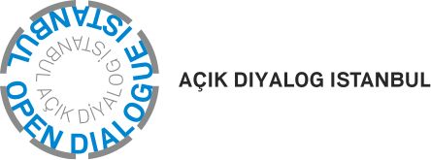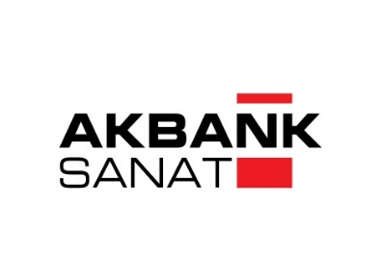

“Curating Contemporary Art” Seminar Program
List of Conditions

“Curating Contemporary Art” is a 7 month-long seminar program organized in cooperation by Open Dialogue Istanbul and Akbank Sanat. The list of conditions required to participate to this program and the information about the program are stated below:

Program Details:
- The program will be held in between the dates of December 2020 – June 2021 / will last 7 Months / 25 Weeks / and will consist of 50 Lessons + 8 workshops / 145 hours long of lessons and the finishing Project.
- It will be realized with a minimum number of 10, maximum number of 20 participants.
- Seminar Venues: Akbank Sanat the digital platform and different prestigious art institutions.
- The seminars to be realized on the digital platform will take place on Mondays between 6:00 – 8:30 pm, and the ones to be realized in Akbank Sanat will take place on Wednesdays between 6:00-8:30 pm.,
- The seminars, internships, field & study trips and the finishing Project will be realized in a time frame of 7 months.
- The participants admitted to the totality of the program and who will complete the program with success will be given a completion certificate.

Participation Conditions:

- Undergraduate and Postgraduate level with degrees from departments such as visual arts, art management, philosophy, sociology, architecture, engineering, political science & economics.

- The participation fee to the program will be as follows:

1) For those participating to the totality of the program, 5.000 TL. + kdv. Per participant.
2) Some of the seminars will also be open to outsiders. The fee per seminar (one seminar= 2,5 hours) was determined as 100 TL. per participant.
- Those who will participate to the whole program can also do the payment in two installments as follows;
First payment (pre-registration period): 24 November 2020
Second payment : 5 January 2020
- The completed and signed Application Form must be sent to the following email address: apply@curatingcontemporaryart.org

- In addition, a motivation letter (maximum 500 words), CV (maximum 2 pages) and answers to the following questions (at least 300 words per question) must be sent to the same address.

- Did you think that art played a unifying role in the international art platform during the pandemic process? In the current time, when it is not possible to physically visit exhibitions, what kind of attitude should art institutions take to keep the audience's attention alive?

- What kind of responsibilities does the curator have towards the society he is in today?

- Could you tell us about a Project you would like to realize within the next two years?

- How would you define authenticity? Could you give us an example for a curatorial project that you found authentic? In which way did you find it authentic?

Application:

- To apply, the documents stated above would have to be sent to the following email address: apply@curatingcontemporaryart.org
- The deadline for applications was determined as 15 November 2020. The applications sent after this date will not be evaluated.
- All participants who have completed the application form will be deemed to have accepted the terms of the conditions.

